CS609 System Programming Solved MCQs + Solved Subjective Questions For Final Term Exam
What are the differences between hardware and software interrupts?

Software interrupts are invoked by means of some software instruction or statement and hardware interrupt is invoked by means of some hardware controller generally. The only difference between them is the method by which they are invoked

How would a procedure written for software interrupt will be different from that written for hardware interrupt?

Write a program that will turn on/off the speaker and connect it with the interval timer whenever
Ctrl+Alt+S is pressed Timer interrupt
#include <dos.h>
#include <bios.h>
void interrupt (*oldint15) ( );
void interrupt newint15 (unsigned int BP, unsigned int DI, unsigned int SI, unsigned int DS, unsigned int ES, unsigned int DX, unsigned int CX, unsigned int BX, unsigned int AX, unsigned int IP, unsigned int CS, unsigned int flags);
void main ( )
{
oldint15 = getvect (0x15); setvect (0x15, newint15); keep (0, 1000);
}
void interrupt newint15( unsigned int BP, unsigned int DI, unsigned int SI, unsigned int DS, unsigned int ES, unsigned int DX, unsigned int CX, unsigned int BX, unsigned int AX, unsigned int CS, unsigned int IP, unsigned int flags)
{
if (_AH = = 0x4F)
{
if (_AL == 0x1F)
{
outport (0x43, 0xB4); outport (0x42, 0xFF); outport (0x42, 0x21);
outport (0x61, inport(0x61) ^ 3);
}
}
else
(*oldint15) ( );
}
CS609 MCQs For Papers
What is the difference between a simple program and a TSR program? How can we stop multiple loading of a TSR program into memory?
TSR (Terminate and Stay Resident) program is a program which programs the interrupt number
65H but in this case the new interrupt 65H function remains in memory even after the termination of the program and hence the vector of int 65h does not become a dangling pointer. A TSR need to be loaded once in memory. Multiple loading will leave redundant copies in memory So we need to have some check which will load the program only once

How interrupts are processed? List down five differences between hardware and software interrupts.
Software interrupts are invoked by means of some software instruction or statement and hardware interrupt is invoked by means of some hardware controller generally.

5w.
hatisnulmlodem2marks

If data is to transferred from one computer to another through some media which can carry digital data then the modem can be eliminated and the UART on both computers can be interconnected. Such arrangement is called a NULL modem

6t.ypesofinterrupts3marks

Interrupt means to break the continuity of some ongoing task. When we talk of computer interrupt we mean exactly the same in terms of the processor. When an interrupt occurs the continuity of the processor is broken and the execution branches to an interrupt service routine.Two types of interrupts are:
Software interrupts
Hardware Interrupts.
DMA stands for DirecMt emoryAcce s .

REGS is a

Size of IVT is 1024 bytes

Set the Interrupt vector means to change the double word sized interrupt vector within IVT.

T/F

Display device (Monitor) performs memory mapped I/O. NMI stands for .

CS609 MCQs For Papers
If keyboard buffer is empty the head and tail points at the same location. T/F

Tail of keyboard should get to get the start of buffer.

Interrupt 65H is empty.

Interval time is used to divide input frequency. T/F

An I/O device cannot be directly connected to the busses so controller is placed between CPU
and I/O.

Standard PC can have PPI.
1, 4, 8, 16

The BIOS int 0x1Ah can be used to configure RTC. Keyboard uses port 64H as status port.
Communication b/w keyboard and keyboard controller is Asynchronous serial
Synchronouserial
Parallel
None
0xF3 means typematic rate will be sent in next byte. By cascading two DMAs bits can be transferred.
4, 8, 16, 32

Timer interrupt occurs 18.2 times in a second.

PPI interconnection bits is cleared to indicate low nibble is being sent. D1, D2, D3D, 4

Write TSR that use 17h to ignore spaces. 5 marks
#include <dos.h>
void interrupt (*old)( ); void interrupt newfunc ( ); main( )
{ old=getvect(0x17); setvect(0x17,newfunc); keep(0,1000);
CS609 MCQs For Papers
}
void interrupt newfunc( )
{
if (_AH==0)
{
if ( _AL != ‘ ‘ ) (*old)();
}
}

Write TSR to display name in center with interrupt 8 provided 1990 is center index. 10 marks
void interrupt (*1990)();
void main()
{ old=getvect(0x08); setvect(0x08,newint); keep(0,1000);
}
void interrupt newint ()
{
…
… (*1990)();
}

www.vustudents.ning.com

If CPUID instruction is not present then the processor can be a
? 486 processor
? 386 processor
? 286 processor
? All of the above
Question No. 2
On the execution of IRET instruction, number of bytes popped from stack is
? 4 bytes
? 6 bytes
? 8 bytes
? 10 bytes
Question No. 3
Keyboard Status Byte is located at the address
? 0040:0000H
? 0040:0013H
? 0040:0015H
? 0040:0017H
Question No. 4
If we use keep (0, 1000) in a TSR program, the memory allocated to it is

? 64000 bytes
? 32000 bytes
? 16000 bytes
? 80000 bytes
Question No. 5
CS609 MCQs For Papers
Maximum number of interrupts in a standard PC is
? 64
? 128
? 256
? 512

In boot block BIOS parameter block starts from
03H
05H
08H
0BH

File can be viewed as collection of clusters or blocks.
Physically
Logically
Both physically and logically
None

What will be the value of DL Register when we are accessing C drive using undocumented service 21H/32H?
0
1
2
3

Operating system name contains bytes in boot block.
3
5
8
11

When LSN is equal to zero (0) it means First block of the disk
First block of the logical drive First block of hidden blocks None of the given

The size of DPB data structure is bytes
16
32

64
128
CS609 MCQs For Papers

Cluster number can also be referred as block number. True
False

Using the entry and the FAT we can access the contents of file. Reserved blocks
Root Directory Number of FAT copies None of the given

Control information in files is maintained using
BPB DPB FCB FPB
We can access blocks for FAT using BPB
DPB
FCB
Both BPB and DPB

File system used in CD’s is file system
Contiguous Chained Indexed None

Disadvantage of FAT32 is Large disk can be managed in FAT32
Cluster size is reduced
Internal fragmentation is reduced
Very large table

Practically entries are there in FAT 32
2^26
2^28
2^30
2^32

NTFS volume can be accessed directly in DOS.
True

False
CS609 MCQs For Papers

What will happen if NTFS volume is accessed in DOS? Convert it to FAT volume
Nothing will happen Error of invalid media None of the given

Advantages of FAT32 is/are Large disk size can be managed in FAT32
Cluster size is reduced
Internal fragmentation is reduced
All of the given

FAT based file system can store file name in form
ASCII UNICODE
Both ASCII and UNICODE
None

How many bytes can be used to store a file name in NTFS?
128
255
510
1024

IN NTFS, FAT and root directory is replaced by
FCB
MFT
Hidden blocks
Boot sector

LSN of FSInfo block is available at
BPB
FAT
Root Directory
None of the given

DOS device drivers do not understand the_ data structures. FAT12
FAT16
FAT32
NTFS

For supporting long file names, fragments can be supported.

CS609 MCQs For Papers
12
20
26
32

If a file is having more than one cluster then it will be managed by
FAT BPB DPB None

File system keeps the backup of its boot block. FAT12
FAT16
FAT32
None

If a file size is 12K and the size of the cluster is 4K then clusters are used for the file.
2
3
4
5

is the first logical sector of NTFS partition. DPB
MFT
Boot sector
None

A file has 2 clusters and the size of cluster is 4K. What will be the size of file?
2K
8K
16K
32K

In FAT32 root directory entries are there
128
256
512
None

Block # 2 is the safest block to store the backup of boot block. True
False
CS609 MCQs For Papers

1. There are two main types of interrupts namely Hardware and Software interrupts

2. To set the interrupt vector means is to change the double word sized interrupt vector within the IVT. (True / False)

3. The service number is usually placed in the register. (AL, CL, AH, AX)

4. The keyboard makes use of interrupt number for its input operations. (9,10,11,12)

5. The service
15H/FFH )
is called the keyboard hook service. (15H/2FH, 15H/4FH,

6. The BIOS interrupt can be used to configure RTC. (1AH, 2AH, 3AH, 4AH)

7. The interval timer can operate in modes. (Five, Seven, Four, Six)

8. is Disk interrupt. (10H,11H,13H,14H)

9. PPI stands for Peripheral Programmable Interface (PPI)

10. Int is used to control the printer via the BIOS. (17H, 18H, 20H, 21H)

CS609 MCQs For Papers

11. Counter register can be used to divide clock signal. (True False) Note : it is also used to divide frequency (See #69)

12. DCE stands for _ Data Communication Equipment

13. Interrupt ID Re gister _is used to identify the cause of interrupt.

14. The bit # of the coprocessor control word is the interrupt enable flag. (7,8,9, 6)

15. There are kinds of serial communication. (2,3,4,5)

16. store the base address for LPT1. (40:00H , 40:02H ,40:08H, 40:1AH)

17. The amount of memory above conventional memory (extended memory) can be determined using the service . (15H/88H, 16H/88H, 17H/88H, 21H/88H)

18. The output on the monitor is controller by a controller called within the PC. (Video controller, Bus controller, Ram controller, None of the given)

19. The keyboard input character scan code is received at port. (60H,61H,62H,63H,64H )

20. is LED control byte. (0xFD,0xED, 0xFF, 0xEE )
21. In RS232C these abbreviations stands for [3 marks]
DTR DTR (data terminal ready)
DSRDSR (data set ready)
CTS CTS (clear to send) RTS RTS (Request to send)

22. For what purpose these services are used? [3 marks]
INT 1AH/01 Set Clock Counter
INT 1AH/02 Read Time INT 1AH/03 Set Time INT 1AH/04 Read Date
CS609 MCQs For Papers
INT 1AH/05 Set Date

23. How communication between modem can performed (in terms of data transfer). [5marks]

Modem is generally used to send /receive data to/from an analog telephone. Had the telephone line been purely digital there would have been no need of a modem in this form. If data is to transferred from one computer to another through some media which can carry digital data then the modem can be eliminated and the UART on both computers can be interconnected. Such arrangement is called a NULL modem.
BY MISHII
Function to toggle speaker between on and off
The port 61h is used to control the speaker only the least significant 2 bits are important. Bit 0 is used to connect the interval timer to the speaker and the bit #1 is used to turn the speaker on off. Rest of the bits are used by other devices.

Parallel communication
PPI is used to perform parallel communication. Devices like printer are generally based on parallel communication. It’s called parallel because a number of bits are transferred from one point to another parallel on various lines simultaneously

Communication with parity check
The line control register contains important information about the behaviour of the line through which the data will be transferred. In it various bits signify the word size, length
of stop bits, parity check, parity type and also the a control bit to load the divisor value.
The bit 7 if set indicates that the base +0 and base + 1 will act as the divisor register otherwise if cleared will indicate that base + 0 is the data register.

RS232C work flow?
RS232C is a standard for physical dimension of the connector interconnecting a DTE(Data terminal equipment) and DCE (Data communication equipment).
Data is received through the RxD line. Data is send through the TxD line. DTR (data terminal ready) indicates that the data terminal is live and kicking. DSR(data set ready) indicates that the data set is live. Whenever the sender can send data it sends the signal RTS( Request to send) if as a result the receiver is free and can receive data it send the sender an acknowledge through
CTS( clear to send) indicating that its clear to send now.

1AH services
Clock Counter 1AH/00
Set Clock Counter 1AH/01
Read Time 1AH/02
Set Time 1AH/03
Read Date 1AH/04
CS609 MCQs For Papers
Set Date 1AH/05
Set Alarm 1AH/06
Disable Alarm 1AH/07
Read Alarm 1AH/09

Write function in relation to COM port and modem
The initialize () function initializes the COM port whose number is passed as parameter using BIOS services. The recievechar() function uses the COM port number to receive a byte from the COM port using BIOS services. the sendchar() function sends a character to the COM port using BIOS service whose number is passed as parameter. And the getcomstatus() function retrieves
the status of the COM port whose number has been specified and returns the modem and line status in an unsigned int.

Coprocesser

To access the block within cluster using BIOS services the cluster number should be converted into .
Select correct option: CHS
LBA
LSN
None of the given

Question # 2 of 10 ( Start time: 12:21:55 PM ) Total Marks: 1
The practical limit of blocks per cluster is . Select correct option:

32 blocks per cluster
64 blocks per cluster
128 blocks per cluster
256 blocks per cluster

Question # 3 of 10 ( Start time: 12:23:05 PM ) Total Marks: 1
Maximum possible entries in FAT12 are . Select correct option:
1024
2048
4096
65536

Question # 4 of 10 ( Start time: 12:24:20 PM ) Total Marks: 1
When we talk about FAT based file system, in user data area first cluster number is . Select correct option:
0
CS609 MCQs For Papers
1
2
None of the given

Question # 5 of 10 ( Start time: 12:25:04 PM ) Total Marks: 1
If we know the cluster number, we can access the blocks within the cluster using BIOS services directly.
Select correct option:

True
False
Question # 6 of 10 ( Start time: 12:26:16 PM ) Total Marks: 1
Jump code part contains bytes in boot block. Select correct option:

3
5
8
11

Question # 7 of 10 ( Start time: 12:27:22 PM ) Total Marks: 1
In dos we have limit of . Select correct option:

128 blocks per cluster
256 blocks per cluster
32 blocks per cluster
64 blocks per cluster

Question # 8 of 10 ( Start time: 12:28:01 PM ) Total Marks: 1
Drive parameter block is derived from . Select correct option:
FCB FAT BPB CPB
Question # 9 of 10 ( Start time: 12:29:26 PM ) Total Marks: 1
The directory structure of DOS is like . Select correct option:

Array Tree Linked list
None of the given
CS609 MCQs For Papers

Question # 10 of 10 ( Start time: 12:30:19 PM ) Total Marks: 1
is the first block on disk. Select correct option:

LSN =0
LBA=0
LBA=1
Both LBA=0 and LSN=0

Question # 1 of 10 ( Start time: 12:20:29 PM ) Total Marks: 1
To access the block within cluster using BIOS services the cluster number should be converted into .
Select correct option:

CHS LBA LSN
None of the given

Question # 2 of 10 ( Start time: 12:21:55 PM ) Total Marks: 1
The practical limit of blocks per cluster is . Select correct option:

32 blocks per cluster
64 blocks per cluster
128 blocks per cluster
256 blocks per cluster

Question # 3 of 10 ( Start time: 12:23:05 PM ) Total Marks: 1
If FAT entry is between FFF0H to FFF6H in FAT16 then . Select correct option:

Cluster is available
It is a Reserved cluster
It is next file cluster
It is a last file cluster

Question # 4 of 10 ( Start time: 12:24:20 PM ) Total Marks: 1
What will be the value of the word located at 1Fh in DPB when number of free clusters on drive is not known?
Select correct option:

0000H

1111H FFFFH
CS609 MCQs For Papers
None of the given.

Question # 5 of 10 ( Start time: 12:25:04 PM ) Total Marks: 1
If we know the cluster number, we can access the blocks within the cluster using BIOS services directly.
Select correct option:

True
False

Question # 6 of 10 ( Start time: 12:26:16 PM ) Total Marks: 1
Jump code part contains bytes in boot block. Select correct option:

3
5
8
11

Question # 7 of 10 ( Start time: 12:27:22 PM ) Total Marks: 1
In dos we have limit of . Select correct option:

128 blocks per cluster
256 blocks per cluster
32 blocks per cluster
64 blocks per cluster

Question # 8 of 10 ( Start time: 12:28:01 PM ) Total Marks: 1
We can access the contents of File by using the root directory entry and . Select correct option:

Reserved Blocks
Number of FAT copies
File Allocation Table (FAT) None of the given

Question # 9 of 10 ( Start time: 12:29:26 PM ) Total Marks: 1
The directory structure of DOS is like . Select correct option:

Array

CS609 MCQs For Papers
Tree

Linked list

None of the given

Question # 10 of 10 ( Start time: 12:30:19 PM ) Total Marks: 1
is the first block on disk. Select correct option:

LSN =0
LBA=0
LBA=1
Both LBA=0 and LSN=0

Question # 1 of 10 ( Start time: 02:32:19 PM ) Total Marks: 1
Disadvantage of FAT32 is . Select correct option:

Large disk size can be managed in FAT32
Cluster size is reduced
Internal fragmentation is reduced
Very large table (not sure)

Question # 2 of 10 ( Start time: 02:33:47 PM ) Total Marks: 1
In FAT32, lower bits are used. Select correct option:

26
28
30
32

Question # 3 of 10 ( Start time: 02:34:23 PM ) Total Marks: 1
File system used in CD’s is file system. Select correct option:

Contiguous
Chained
Indexed (guess) None of the given
CS609 MCQs For Papers Question # 4 of 10 ( Start time: 02:35:53 PM ) Total Marks: 1
If a file size is 12K and the size of the cluster is 4K then clusters are used for the file. Select correct option:

2
3
4
5

Question # 5 of 10 ( Start time: 02:37:23 PM ) Total Marks: 1
To store a UNICODE character is/are needed. Select correct option:

Nibble
Byte
2 Bytes
4 Bytes

Cluster size is reduced in . Select correct option:

FAT12
FAT16
FAT32
None of the given

Question # 7 of 10 ( Start time: 02:40:18 PM ) Total Marks: 1
For supporting long file names, fragments can be supported. Select correct option:

12
20
26
32

Question # 8 of 10 ( Start time: 02:41:28 PM ) Total Marks: 1
A file has 2 clusters and the size of cluster is 4K. What will be the size of file? Select correct option:

2K
8K
16K
32K
CS609 MCQs For Papers

In NTFS, Backup of boot block is stored at block # . Select correct option:

2
6
8
10

Question # 10 of 10 ( Start time: 02:44:18 PM ) Total Marks: 1
When we mark a file as deleted by placing 0xE5 then the chain of clusters in FAT is also replaced by .
Select correct option:

E5
1
0
N

Quiz: CS609 Total Marks 10
Instructions:
1) Upload this Quiz after solving with in 24 hours No Extra Time will be given or Quiz will not be accepted via email.
2) Do No mark more then one choices.
3) It is better you high light the choice with Read like a) correct choice

1) The interval timer can operate in modes.
a) Three b) Four c) Five d) Six

2) Highest capacity physical capacity of the disk according to the IDE interface is
. a) 127GB b) 100 GB
c) 80 GB
d) 300 GB

3) Partition Table can be read using the extended Services.
a) 13 H
CS609 MCQs For Papers
b) 14 H
c) 15 H
d) None of given

4) File control block (FCB) is byte long.
a) | 32
b) | 64
c) | 16
d) | 128

5) On the execution of IRET instruction, number of bytes popped from stack is

a) 4 bytes b) 6bytes c) 8 bytes d) 10 bytes

6) If CPUID instruction is not present then the processor can be a
a) 486 processor b) 386 processor c) 286 processor
d) All of the given choices

7) Extended memory is available if the processor is of the type
a) AT
b) XT
c) All of the given choices d) None of them

8) The built in mechanism within the UART for error detection is
a) hamming code b) parity
c) CRC16 (cyclic redundancy check 16 bit )
d) CRC32 (cyclic redundancy check 32 bit )

9) In Protected Mode, the segment registers are used as
a) Descriptor b) Selector
c) All of the given choices
d) None of the given choices

10) If three Programmable interrupt controllers are cascaded then how many interrupt driven hardware IO devices can be attached
CS609 MCQs For Papers
a) | 12
b) | 18
c) | 23
d) | 24

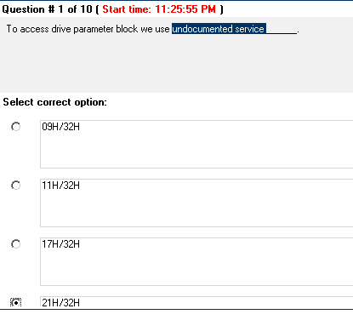
CS609 MCQs For Papers

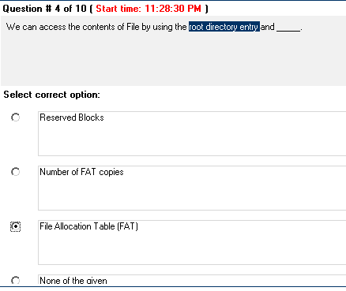

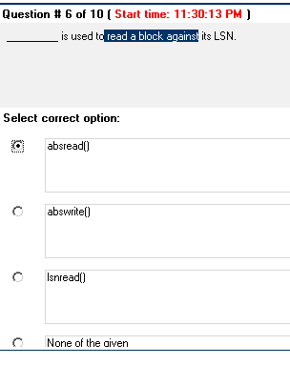
CS609 MCQs For Papers

First block on logical drive.

LBA
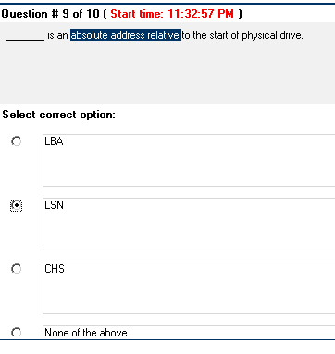

3/2
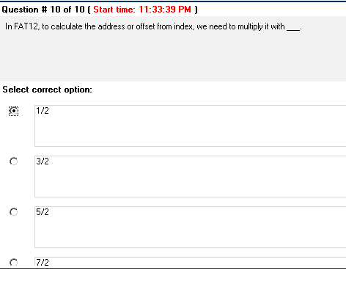

CS609 MCQs For Papers

CS609 MCQs For Papers

FALSE

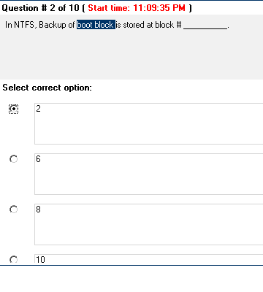

2^28
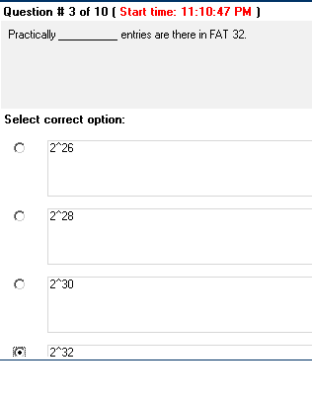

CS609 MCQs For Papers

26
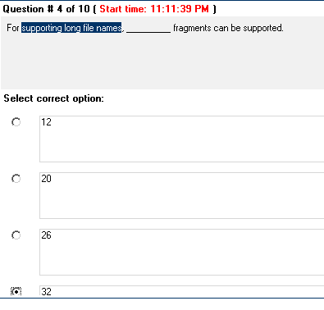

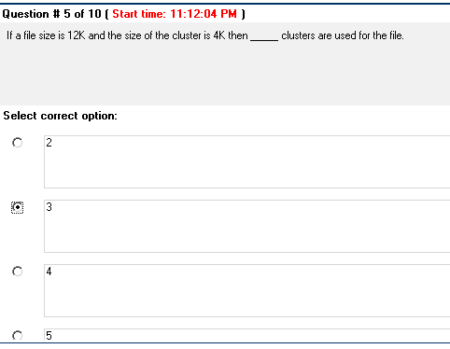
CS609 MCQs For Papers

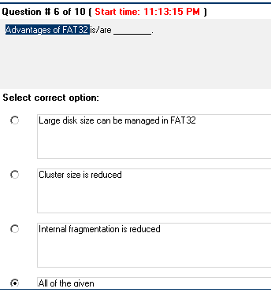
CS609 MCQs For Papers

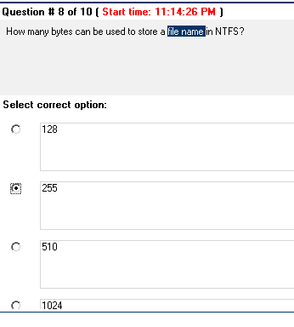

DPB
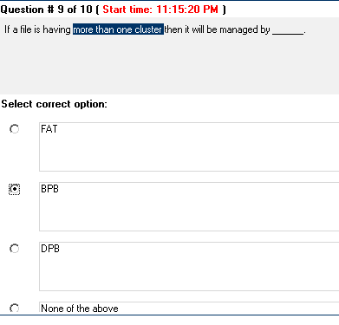

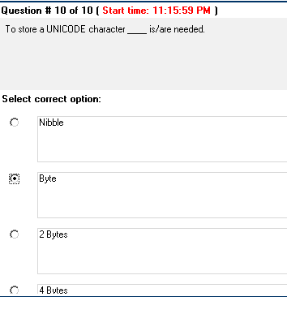

CS609 MCQs For Papers

There are two main types of interrupts, namely

PC based and Window based
Hardware based and Kernal based
Hardware interrupts and Software interrupts
None of the given

Question No: 2 ( Marks: 1 ) - Please choose one
Standard PC operates in two modes in terms of memory which are

Real mode and Extended Mode Base mode and Memory Mode None of the given
Real mode and protected mode

Question No: 3( Marks: 1 ) - Please choose one
BPB stands for .

BIOS parameter block BIOS processing block Base processing block BIOS partition block

Question No: 4 ( Marks: 1 ) - Please choose one
The Function of I/O controller is to provide .

I/O control signals
Buffering
Error Correction and Detection
All of given

Question No: 5 ( Marks: 1 ) - Please choose one
IVT is a table containing byte entries each of which is a far address of an interrupt service routine.

2
4
8
16

Question No: 6 ( Marks: 1 ) - Please choose one
Each paragraph in keep function is bytes in size.
CS609 MCQs For Papers

8
16
32

Question No: 7 ( Marks: 1 ) - Please choose one
Interrupt 9 usually reads the from keyboard.

ASCII code
Scan code
Both ASCII and Scan code
None of the above

Question No: 8 ( Marks: 1 ) - Please choose one
A software interrupt does not require EOI (End of interrupt).

True
False

Question No: 9 ( Marks: 1 ) - Please choose one
To store each character in keyboard buffer bytes are required.

2
4
6
8

Question No: 10 ( Marks: 1 ) - Please choose one
Interrupt is empty; we can use its vector as a flag.

9H
13H
15H
65H

Question No: 11 ( Marks: 1 ) - Please choose one
Command register is an bit register
4
8
16
32

Question No: 12 ( Marks: 1 ) - Please choose one
The interval timer can operate in modes.

Three Four Five Six

Question No: 13 ( Marks: 1 ) - Please choose one
The following command “outportb (0x61,inportb(0x61) | 3);” will .

Turn on the speaker Turn off the speaker Toggle the speaker None of the above

Question No: 14 ( Marks: 1 ) - Please choose one
The PPI acts as an interface between the CPU and a parallel .

I/O device
CPU BUS
None of Given

Question No: 15 ( Marks: 1 ) - Please choose one
DTE is .

Data terminal equipment Data transmitting equipment Dual terminal equipment None of the given.

Question No: 16 ( Marks: 1 ) - Please choose one
DSR stands for .

Data set ready Data service ready Data stock ready None of the given

Question No: 17 ( Marks: 1 ) - Please choose one
In self test mode the output of the UART is routed to its input.

True
False
Question No: 18 ( Marks: 1 ) - Please choose one
Interrupt is used to get or set the time.

0AH
1AH
2AH
3AH

Question No: 19 ( Marks: 1 ) - Please choose one
is used to set time.

1A/02H
1A/03H
1A/04H
1A/05H

Question No: 20 ( Marks: 1 ) - Please choose one
Communication between keyboard and keyboard controller is .

Asynchronous serial Synchronous serial Parallel communication None of the given
)
Question No: 1 ( Marks: 1 ) - Please choose one
Following is not a method of I/O

Programmed I/O Input driven I/O Hardware Based I/O None of given

Question No: 2 ( Marks: 1 ) - Please choose one
The Function of I/O controller is to provide .

I/O control signals
Buffering
Error Correction and Detection
All of given

Question No: 3 ( Marks: 1 ) - Please choose one
Which of the following are types of ISR .

BIOS (Basic I/O service ) ISR DOS ISR
ISR provided by third party device drivers
All of the given

Question No: 4 ( Marks: 1 ) - Please choose one
Interrupt service number is usually placed in register.
CH CL AH AL

Question No: 5( Marks: 1 ) - Please choose one
NMI Stand for

Non Maskable Interrupt Non Multitude Interrupt Non Maskable Instruction None of Given

Question No: 6 ( Marks: 1 ) - Please choose one
A single interrupt controller can arbitrate among different devices.

4
6
8
10

Question No: 7 ( Marks: 1 ) - Please choose one
Hardware Interrupts are .

Preemptive
Non-Preemptive
Both Preemptive and Non-Preemptive
None of Given

Question No: 8 ( Marks: 1 ) - Please choose one
The microprocessor package has many signals for data. Below are some in Correct priority order (Higher to Lower).

Reset,Hold,NMI,INTR
NMI, INTR,Hold,Reset INTR,NMI,Reset,Hold None of the Given

Question No: 9 ( Marks: 1 ) - Please choose one
The interval timer can operate in modes.

Three Four Five Six

Question No: 10 ( Marks: 1 ) - Please choose one
PPI stands for .

Parallel Programmable interface Peripheral Programmable interface Port Programmable interface
None of the given

Question No: 11 ( Marks: 1 ) - Please choose one
The following command “outportb (0x61,inportb(0x61) & 0xFC);” will

Turn on the speaker Turn off the speaker Toggle the speaker None of the given

Question No: 12 ( Marks: 1 ) - Please choose one
The PPI acts as an interface between the CPU and a parallel .

I/O device
CPU BUS
None of Given

Question No: 13 ( Marks: 1 ) - Please choose one
BIOS DO NOT support .

LPT1
LPT2
LPT3
LPT4
Question No: 14 ( Marks: 1 ) - Please choose one
bit is cleared to indicate the low nibble is being sent.
D1
D2
D3
D4

Question No: 15 ( Marks: 1 ) - Please choose one
The bit of Line control register in UART, if cleared will indicate that DLL is the data register.

1
3
5
7

Question No: 17 ( Marks: 1 ) - Please choose one
used to determine the amount of conventional memory interfaced with the processor in kilobytes.

INT 10 H INT 11 H INT 12 H INT 13 H

Question No: 18 ( Marks: 1 ) - Please choose one
Bit number of coprocessor control word is the Interrupt Enable Flag.

7
8
9
10

Question No: 19 ( Marks: 1 ) - Please choose one
To distinguish 486 with Pentium CPUID Test is used.

True
False

Question No: 20 ( Marks: 1 ) - Please choose one
is LED control byte.

0xF3
0xED
0xE5
0xFF

2. Int service 0 can be used to set the line parameter of the UART or COM port.
14H
15H
13H
None of the given option
3. In case of synchronous communication a timing signal is required to identify the start and end of a bit.
True
False

4. In self test mode the output of the UART is routed to its input
True
False
6. The fuction uses the COM port number to receive a byte from the COM port using
BIOS services. recievebyte() receive() recievechar()

10. The function initialize the COM port whose number is passed as parameter using BIOS services.
Initializecom() Initialize() Recievechar()
None of these option

11. XON whenever received indicates the start of communication and XOFF whenever received indicates a temporary pause in the communication.

14. is a device incorporated into the PC to update time even if the computer is off.
Clock counter
ROM Clock
Real time clock

What is the location of timer count in BIOS data area?
Sol.
0040:006C

Question No: 22 ( Marks: 3 )
Write a function which fills the whole screen with blanks (space). Sol.
unsigned char far *scr= (unsigned char far*)0xb8000000 void main()
{
int i;
for (i=0; i<2000; i++)
{
*scr=0x20;
*(scr+1)=0x07;
scr=scr+2;
}
}

Question No: 23 ( Marks: 5 )
For what purpose the port 61H is used? Sol
The port 61h is used to control the speaker only the least significant 2 bits are important. Bit 0 is used to connect the interval timer to the speaker and the bit #1 is used to turn the speaker on off. Rest of the bits are used by other devices.

Question No: 24 ( Marks: 10 )
Write down a C program that will protect the boot block to be written by other application.
Hint.
Use interrupt 13 for accessing the boot block information. Sol.
#pragma inline
#include <dos.h>
#include <bios.h>
void interrupt (*oldtsr) ( );
void interrupt newtsr (unsigned int BP, …, flags);
//must provide all the arguments
void main ( )
{
oldtsr = getvect (0x13); setvect(0x13, newtsr); //corrected keep (0, 1000);
}
void interrupt newtsr(unsigned int BP, unsigned int DI,
unsigned int SI, unsigned int DS, unsigned int ES, unsigned
int DX, unsigned int CX, unsigned int BX, unsigned int AX, unsigned int IP, unsigned int CS,
unsigned int flags) //corrected
{
if ( _AH == 0x03)
if(( _DH == 1 && _CH == 0 && _CL == 1)&& _DL >= 0x80)
{
asm clc;
asm pushf;
asm pop flags;
return;
}
_ ES = ES; _DX = DX;
_CX = CX; _BX = BX;
_AX = AX;
*oldtsr;
asm pushf;
asm pop flags;
AX = _AX; BX = _BX; CX = _CX; DX = _DX; ES = _ES;
}
MIDTERM EXAMINATION
Spring 2009
CS609- System Programming (Session - 1)
Question No: 21 ( Marks: 2 ) ICW and OCW stand for?
Sol.
Initialize control words, operation control words

Question No: 22 ( Marks: 3 )
What is the usage of Interrupt ID Register within the UART?
Sol.

Once an interrupt occurs it may be required to identify the case of the interrupt. This register is used to identify the cause of the interrupt.
Interrupt ID Register
0 bit for Trigger Triggered
2 1 bits for Modem/Line
00 =Change in Modem Status
01 = THR is Empty
10 = Data is Ready
11 =Error in Data

Question No: 23 ( Marks: 5 )
Write a program that surpasses the input of ‘s’ from keyboard. Scan code of ‘s’ is 0x1F.
#include <dos.h>
void interrupt(*old)(); void interrupt newint9(); void main()
{
old=getvect(0x09); setvect(0x09,newint9); keep(0,1000);
}
void interrupt newint9()
{
if (inportb(0x60)==0x1F) //corrected
{
outportb(0X20,0x20);
return;
} (*old)();
}

Question No: 24 ( Marks: 10 ) Explain FIFO Queue in UART. [5]
This feature is available in the newer version of the UART numbered 16500. A queue or a buffer of the input or output bytes is maintained within the UART in order to facilitate
more efficient I/O. The size of the queue can be controlled through interrupt ID register. slide.

Write down the structure of Modem control register. [5]
26 question thy or 6 subjective
jis mein aik hi coding i or wo b handout se hi
or last question tha k keyboard cpu se kesy interact kar k interupt generate karta hai ... diagram k sath
or abrevation sub yad karin
objective mein bth hi question thy aberivation se mutaliq or ziada concetration subjective pe rakihin
coding ka itna nahi aea paper mein

Total 26 Questions..
20 mcsqs are from that file which i sent u yesterday...almost all mcqs..

Then 21st question is the Write the base adresses of LPTs. Sol.
LPT1=40:08, LPT2=40:0A, LPT3=40:0C, LPT4=40:0E

22nd is the abriviations of the internal registers of UARTS e.g THR,RBR etc

23rd What is the value of LEDs (from last lecture)

24th i forgot same from the last lecture about LED.
25th is a 5 marks programm.
26th is the diagram and explaination of the STATUS REGISTER A of the RTL.

Q (5 marks)
Explain the usage of XON and XOFF is software based flow control
Ans (Page # 158 , lec # 17)

Q
Write a function that will read the status of COM Port and return the modem line status is a unsigned int. COM port number will be passed as parameter.

Q Write down the purpose of int 12H and int 15H/88H Ans : int 12H : used for memory interface
int 15H/88H return = No. of kb above 1 MB

Q
Write down the detail of the Service (00,01,02) of int 17H which is used in printer.

Ans : 00 : Display characters
01 : Initialze Printer
02 : Request printer.

some questions of Another Paper. Q (2 Marks )
write stands for
THR transmitter holding register RBR receiver buffer register DLL (band rate divisor) low DLM (band rate divisor) high

Q
write stands for. DSR Data set ready
DTR Date terminal ready
RTS ready to send
CTS clear to send

Q#4:-
a. Write down three differences between Logical Sector Number (LSN) and Logical Block
Addressing (LBA).
b. What is meant by polling mode in communication between software and UART and what is its disadvantage as compared to interrupt mode. [max 5 line answer]

Q#5:-In IRQ2 and IRQ3 which one has the highest priority?
• Can’t be determined
• Both have same priority
• IRQ3
• IRQ2

Q#6:-Extended memory is available if the processor is of the type
• None of the given choices
• All of the given choices
• XT
• AT

Q#7:-In NTFS, boot sector is stored at
• First and 6th sector
• First and Last sector
• Only at Last sector
• Only at First sector

Q#8:-DMA driven IO is the technique used for performing IO
• All of the given choices
• By transferring the data directly from IO port to processor and vice versa
• By using the processor to perform an IO routine only when data for IO operation is available.
• By keeping the processor tied up either checking for the possibility of an IO operation or
performing the IO operation

Q#9:-A full duplex communication system is to be implementing using a PPI (peripheral programmable interface). By the virtue of the printer interface provided by the standard PCs the unit of data transfer for such communication will be
• A double word
• A word
• A byte
• A nibble
what is a Descriptor 2marks
waht is a segment memory and write its attribute 5marks what size of enteries of GDT,LDT and IDT 3marks
what is the contiguous Memory Management waht is FAT12 and 32 entries size 2marks
IN NTFS,the FAT and root directory has been replaced by ........ 2marks write the aotonmy of NTFS 5marks
redundant
Q # 1 [Markes:5]
Write down the structure of segment register in protected modes? Q # 2 [Markes:5]
Write down the anatomy of NTFS based file system? Q # 3 [Markes:5]
Find the root directory sector where reserved sectors = 1 and sector per FAT = 9. Use appropriate assumption where needed.
Q # 4 [Markes:3]
How many maximum root directory entries are possible in FAT 12 & FAT 16? Q # 5 [Markes:3]
What is the CHS and LBA address of MBR? Q # 6 [Markes:3]
Write down the names of three different states of viruses. Q # 7 [Markes:3]
How contents of small and large files are managed in MFT ? Q # 8 [Markes:2]
What is the segmentation is context of non contiguous memory management system? Q # 9 [Markes:2]
Write down the major enhancement of FAT32 comparing to FAT12 and 16. Q # 10 [Markes:2]
Write down the purpose of interrupt 12H and interrupt 15H/88H. Q # 11 [Markes:2]
For what he purpose services are used
Interrupt
1AH /06
1AH /07
1AH /09
Single Transfer in DMA (2 marks)
what kind of data send to the keyboard (2 marks)
Undocumented Services (2marks) Highest IDE capacity biosdisk() (2marks)
In NTFS, FAT32 we replace the root directories with ?(2marks)
hand out Page#64 (3marks)
Multiple loading will leave redundant copies in memory
answer given below:- int flag;
flag =1; keep(0,1000); if (flag==1) Make TSR else
exit Program

logical to physical address translation? (3marks)
What is MFT? (3marks)
what is the contiguous Memory Management (3marks)
what size of enteries of GDT,LDT and IDT (3marks)

Differenciate b/W LSN and LBA (5marks)
anatomy of an NTFS (5 marks)
write the step of Virus Detection (5marks)

